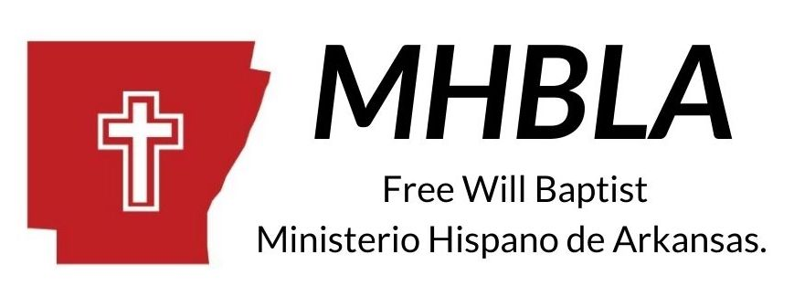
4/16/2021

Report.

To the glory of God, we continue to move forward and work according to God's plan and will. We have had a difficult time, with COVID 19, but we hope to resume and continue faithfully in the work of the ministry in this year 2021. We trust in God, we have faith, and we want to continue growing for the glory of Him.

Hispanic churches.
- North Little Rock. Ten people gathered: Pastor Cesar Barrios.
- Conway. Nine congregants: Missionary Rolando Delgado.
- Russellville. 35 people meeting: Pastor Abdiel Gonzales.
- Danville. 35 parishoners: Pastor Jeremías Hernández
- Dardanelle. 18 people: Pastor Juan Martínez.
- Springdale. 18 congregants: Pastor Armando Acevedo
- Jonesboro. Six congregants: Missionary Rolando Delgado.
- Star City: 28 parishioners: Pastor Mikael Gonzales.

Bible institute.
We now have two Bible Study sites, with a total of 21 students.
- At Atkins, with 12 students.
- In Springdale, with 9 students.

We continue to hold one Pastors Retreat per year in October. We celebrate the Hispanic Missionary Conference every year. We meet with all the churches at a summer camp in August.

We continue working with the purpose of planting new Churches in new cities, as we have the opportunity.

Brothers, thank you for your support and prayers, and we want to continue to count on your support for the Hispanic community in Arkansas.

Arkansas Free Will Baptist Hispanic Ministry
Rolando Delgado, Missionary / Director.

