Arkansas Student Ministries
2020 Student Ministries Director’s Report
“Influencing Today … Impacting Tomorrow”

ASM Director -- Rev. Brian M. Kesterson
________________________________________________________________________

The year of 2020 … what a crazy year. 2020 proved to be a year of challenges, changes and cancelations, frustrations and flexibility, and of course, destruction and construction. There is no doubt that 2020 impacted everyone's lives, forcing each person to think "outside the box" while remaining focused on daily tasks.

For Arkansas Student Ministries (ASM), there were holes created in the ministry. The team experienced voids left behind with the absence of students on campus, challenges with in-person connection affected by great distances and staying committed to fulfilling the mission: ASM exists to glorify God through supporting of the local church by providing various events, training, and encouragement for the students and the student workers in our state.

I want to personally thank everyone who has given sacrificially, both financially and their time over the past year. Throughout the year, individuals reached out expressing their continued prayers and support of the ASM board's efforts as the face of the ministry required adjustment. The ASM board faced some difficult questions and was forced to reconcile with unforeseen and unwanted decisions. But through it all…God prevailed, and we were reminded that God is never surprised by the situations.

EVANGELISM

2020 Camp Season: With the challenges of Covid-19, the board held “Day Camps” in place of the usual overnight camps. Four age-appropriate day sessions were held to provide students the opportunity to experience a camp setting. Each day consisted of fun, food, and fellowship. Evangelism remained a top priority as students attended services to close out each day. 154 Campers and Staff participated in the day camps at Camp Beaverfork. I want to thank all of those that came and worked last year. Lives have been changed because of your sacrifices.

2020 Rental: Within 48 hours, as the governor of Arkansas shut down the state with heavy regulations and mandates, ASM lost all contracted rentals for 2020. This loss was expected due to the social circumstance; however, it became a substantial financial burden. Rentals provide 1/3 of the operational budget. Though the organization was hit with a great loss, it provided open doors for opportunities that were yet to be seen at the first of the year

ENCOURAGEMENT

2020 Winter Retreats: We had a good attendance of both the Kid’s Retreat and the Teen Retreat. During these retreats, our youth experienced the strong preaching of Gods’ Word by Thomas Lovett (Kids Retreat) and Trent Bradley (Teen Retreat).

EQUIPPING

2020 State CTS Expo / Vertical Three Conference: What has become a staple in many churches over the years is students participating in the CTS Expo. Before making the difficult decision to cancel the 2020 Expo, 197 entries were submitted to the ASM office. Knowing how much work and effort goes into preparing and studying for the CTS Expo, it was devastating to see this event canceled. However, I remain confident that the actions of these students did not return void. Each bible verse memorized, every chapter absorbed, each hour of practice provides students the ability to grow spiritually and hon their skills and talents that will continue to be used to advance the kingdom.

OUT OF THE GROUND

In the fall of 2019, the ASM board launched a state-wide fundraiser to begin moving forward with constructing a new kitchen/dining facility. In January of 2020, approximately $187,000 had been raised towards the $1.2 million project. Looking at the months ahead with scheduled services and fundraising activities, the construction goal looked promising. However, with Covid-19, the board pushed this project from the priority list, as the task survival took the lead.

In September, the board received a call that changed everything. After several hours of sharing the heart of the ministry, the impact on students, and the vision, the board received a gift for $800,000, allowing the raised funds to exceed a million dollars. Immediately, the process of construction started with a completion deadline of June 1, 2021.

It has been refreshing to watch God move in a mighty way during the construction process. Each time defeat or frustration would enter my mind, this only exposed God's provisional hand. Construction efforts are on track, and we look forward to utilizing this new facility in 2021 as Camp Beaverfork celebrates 50 years of ministry on "The Hill."

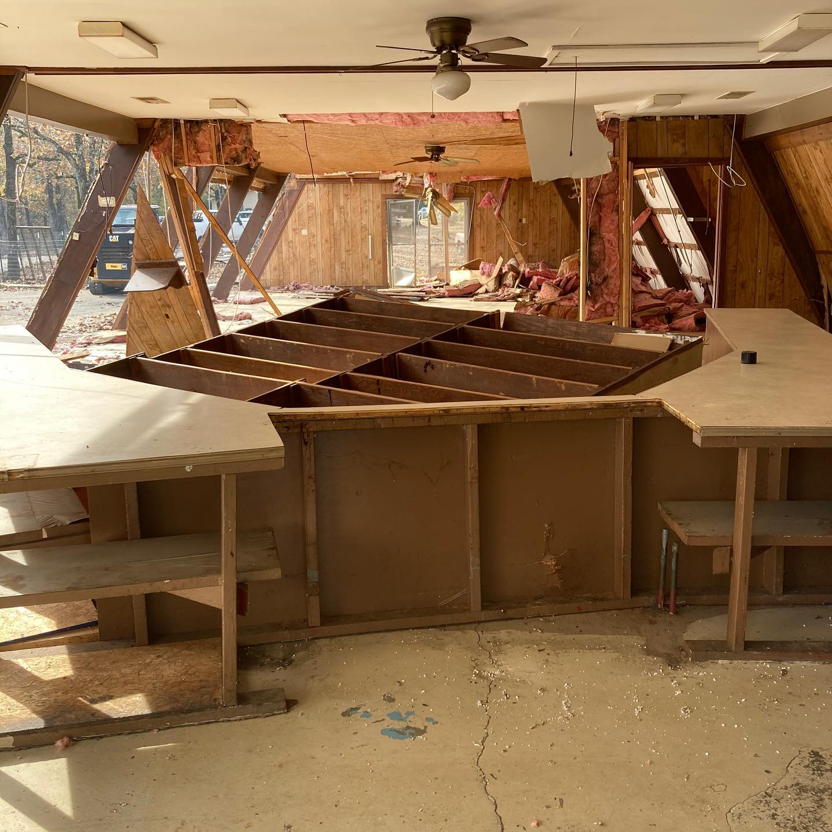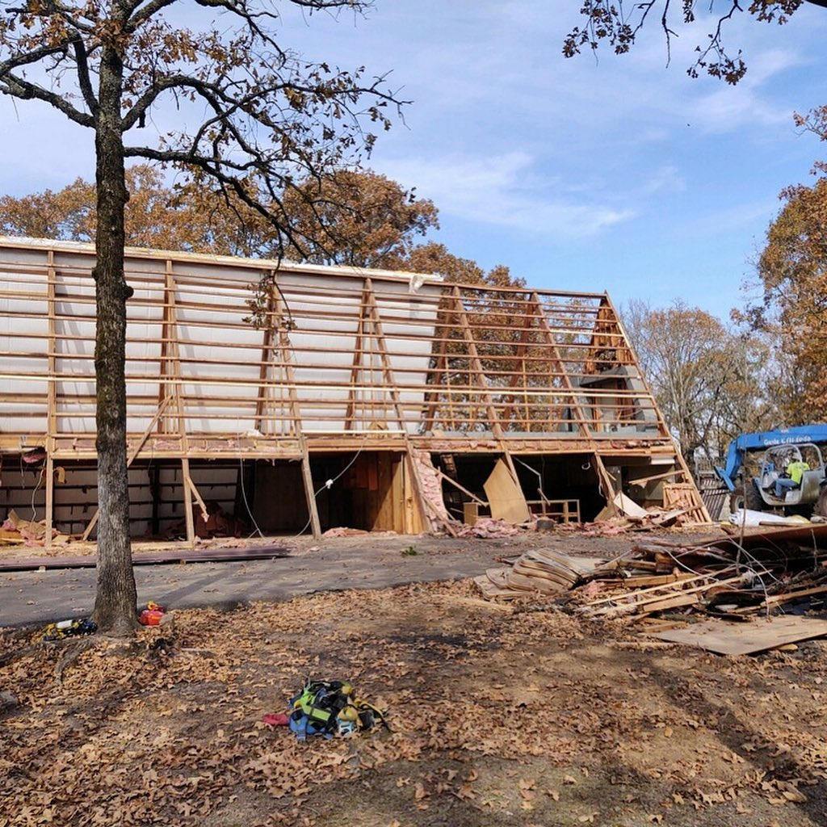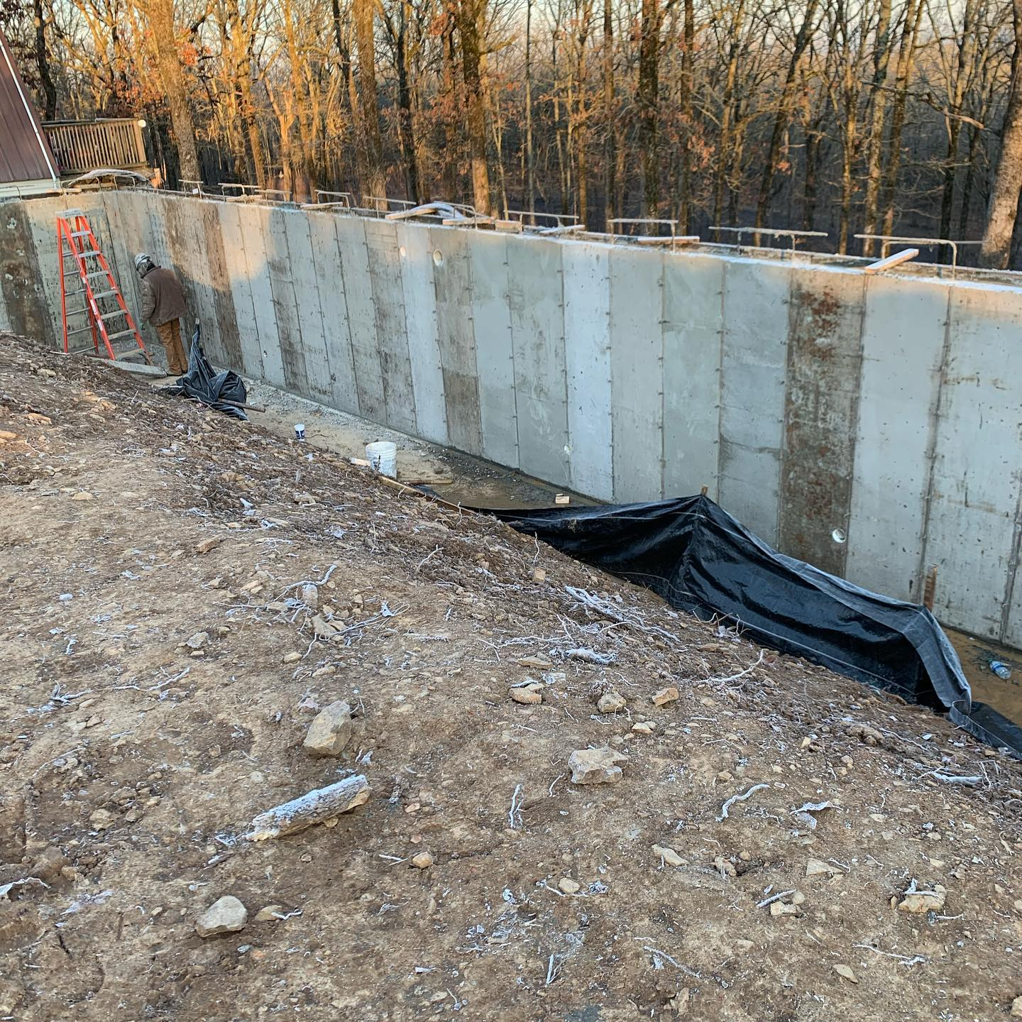

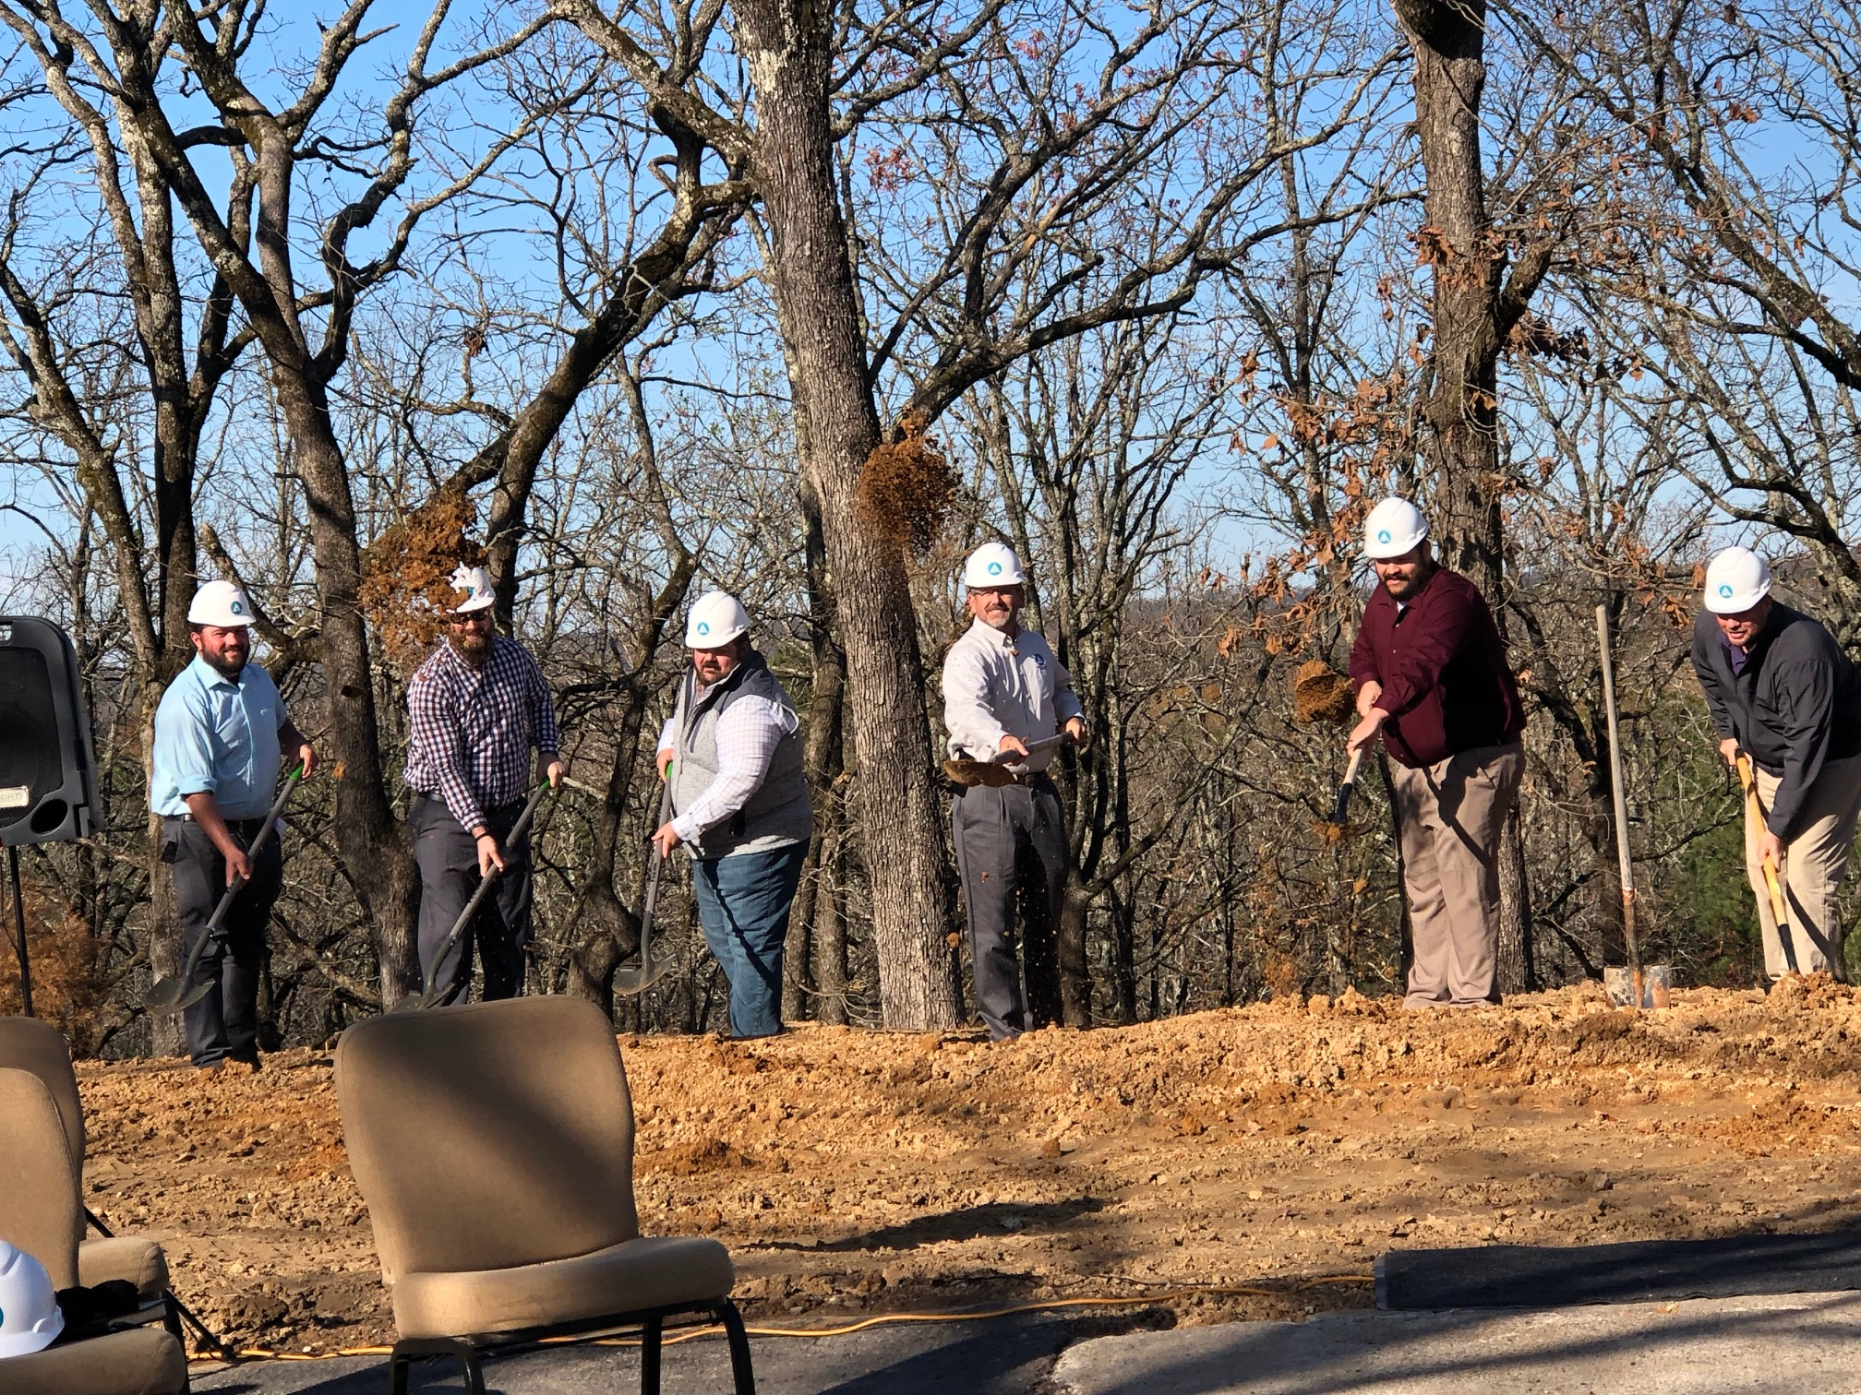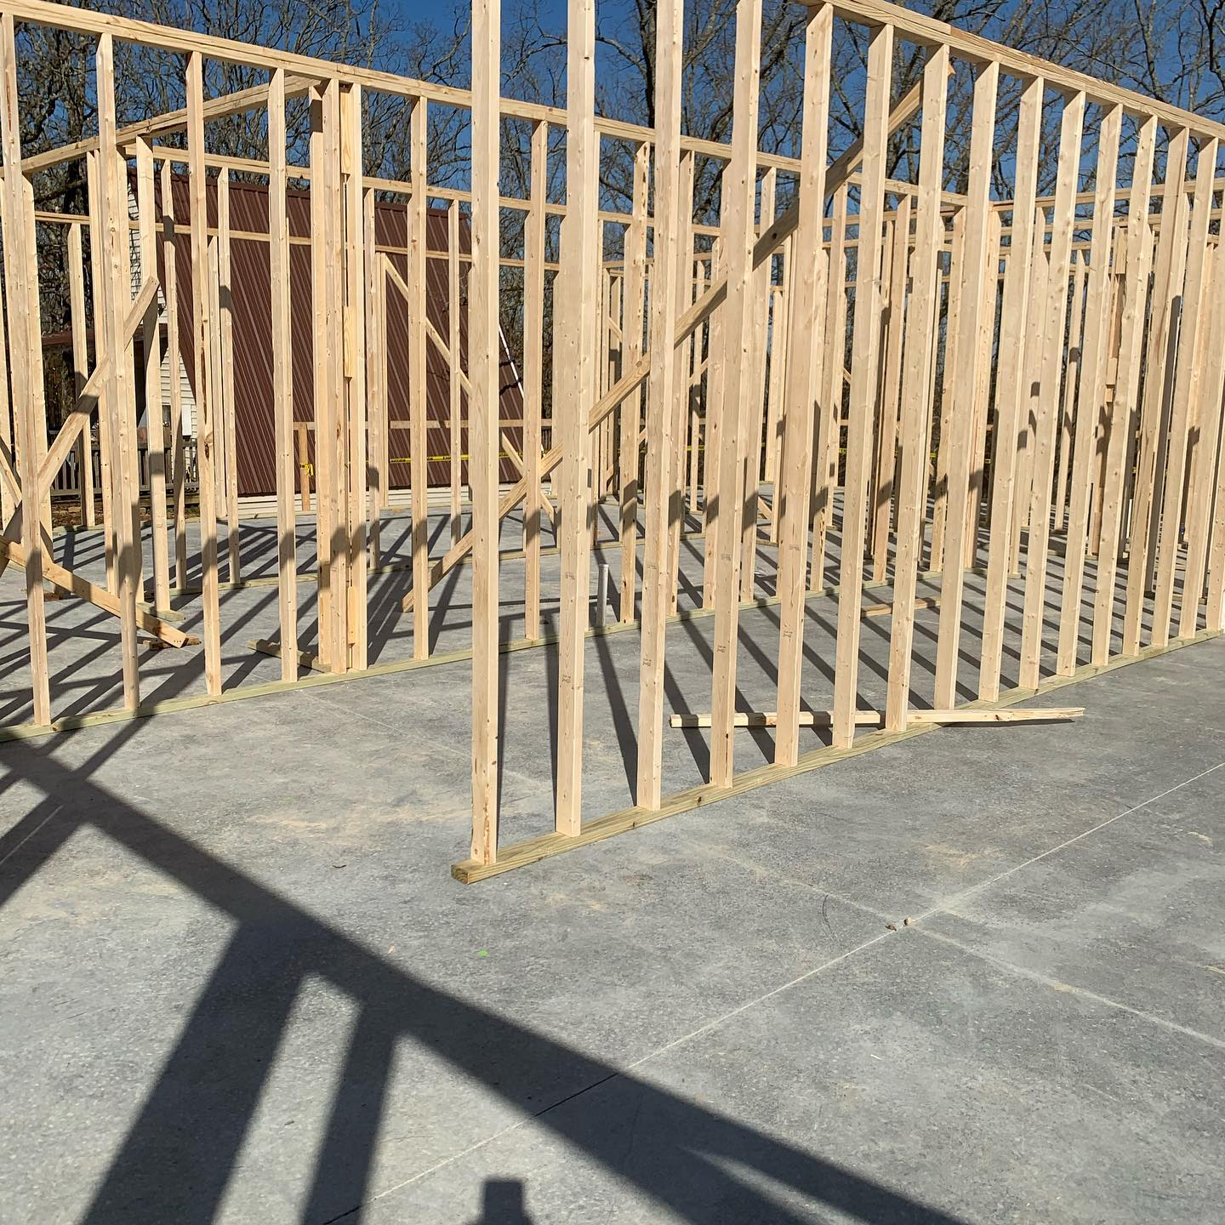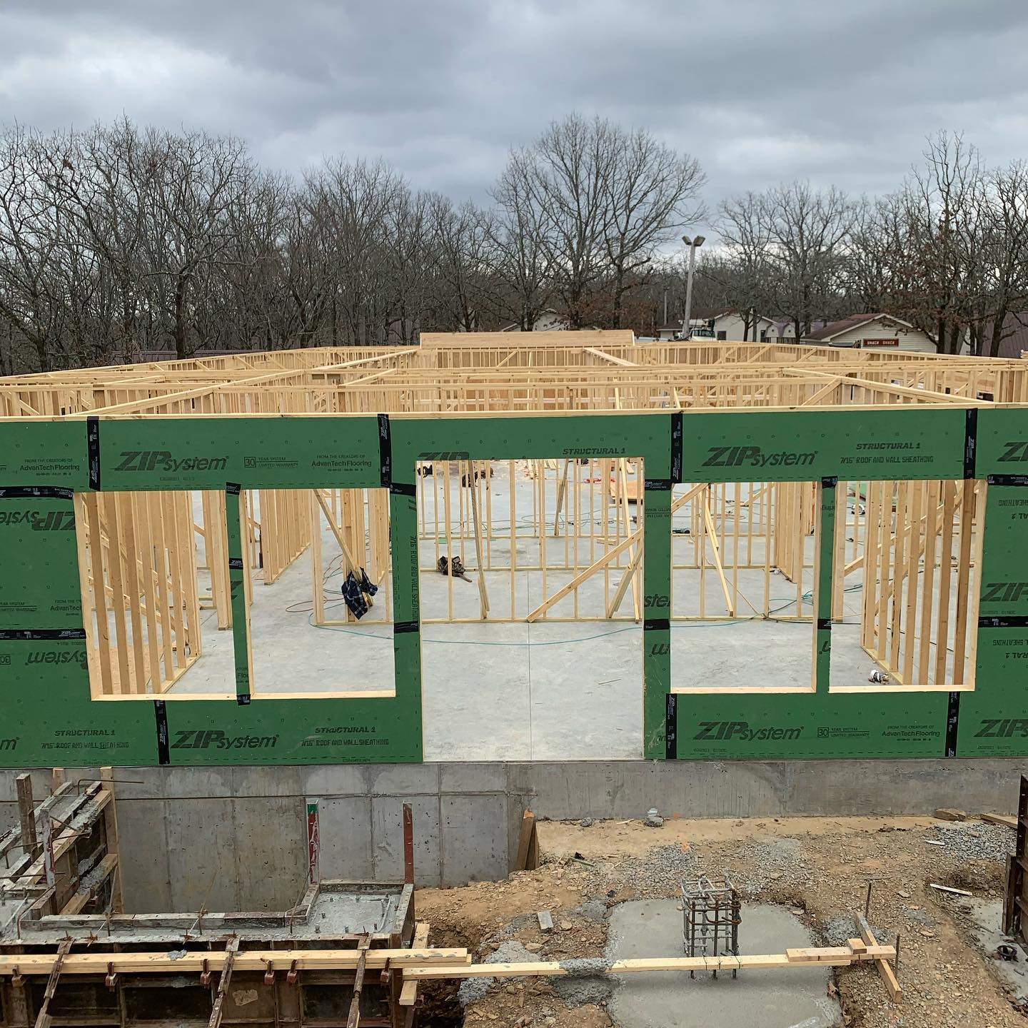
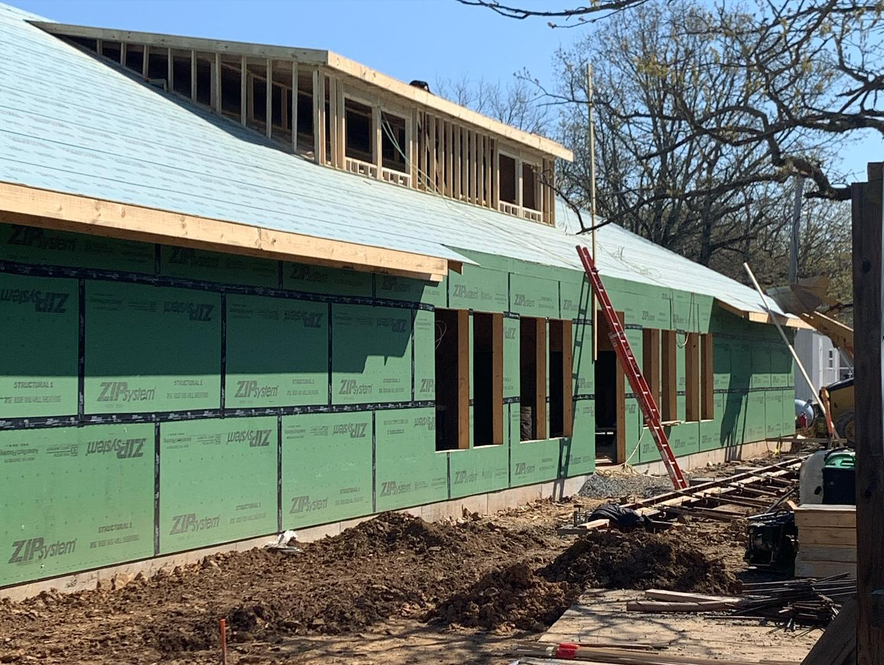

Thank you, Arkansas FWB, for your support of AR Student Ministries as we reach out to make an “Impact” in the lives of AR youth.

